# Build the following 7 by 7 table inserting in the information asked for.

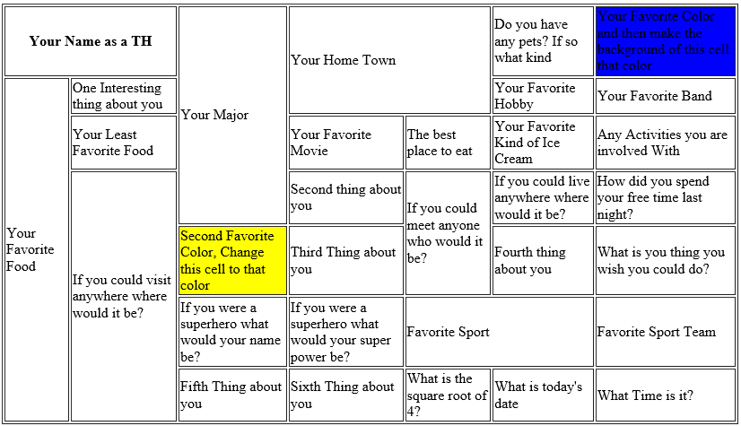

## In your Style Sheet

**Table Properties** – Change the border width, style, color. Set the width of the table to 75%.

**TH** – Change background color; make font larger than rest of table, make font color an opacity color.

**First Row** – Make the vertical alignment to top

**Second row** – change the background color and font color

**Third row** – change the background and font color

**Fourth row** – make the vertical alignment bottom

**Fifth row** – make the text alignment center

**Sixth Row** – Change 3 properties of your choice

**Seventh Row** – change the background and font color